Design document
Group name: The power rangers
Members: Casper, Han, Pleun, Toon, Ian


System overview 2
Load balancing modes overview 3
Communication protocol 4
Hardware design 13
Microcontroller 13
Current measuring 13
Current limiting 14
Software design 15
Inleiding 16
JSON 16
Mogelijke opstelling van het JSON-bestand 17
Werking in de software 18

System overview
General description of the project including overview diagram
This system simulates a decentralized power load balancing solution for an office building with electric vehicle charging stations. The Building ESP32 calculates available power based on grid capacity, office consumption, and solar input, then broadcasts this the left-over power to all Charging Station ESP32s. Each station independently determines how much power it can use by syncing with other stations to detect how many are online and applying the selected load balancing mode (Static, Dynamic, First-Come-First-Serve, or Directors Parking). Charging stations send their status back to the dashboard ESP32, which displays the data coming from the charging stations, enabling real-time monitoring. Peer-to-peer communication ensures robustness and scalability without centralized control.
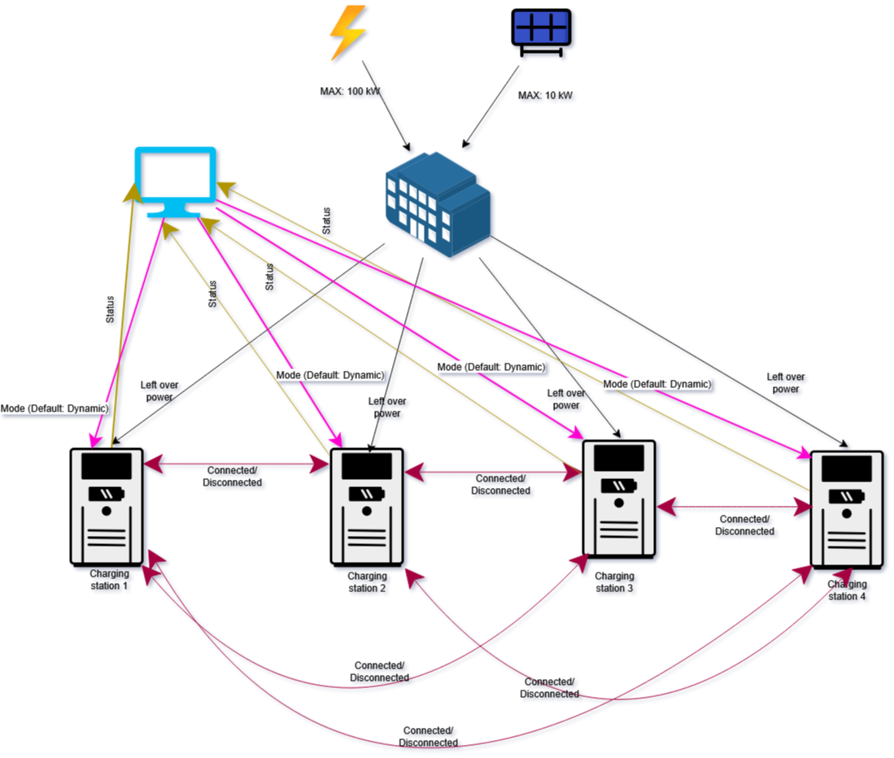

Load balancing modes overview
This system supports four load balancing modes to manage how available power is distributed across electric vehicle charging stations. Each mode ensures the total consumption never exceeds the building’s 100 kW limit, while adapting to real-time conditions like car presence and solar input.
1. Static Load Balancing
Power is evenly divided among all charging stations, regardless of whether a car is connected. This mode is simple but may waste power if some stations are idle.
2. Dynamic Load Balancing
Available power is equally shared only among stations with active charging sessions. This ensures efficient use of energy and adapts to the number of connected vehicles.
3. First-Come-First-Serve (FCFS)
Cars are charged in the order they arrive. Each gets up to 11 kW until capacity runs out. Later arrivals may receive reduced power or wait until earlier cars finish charging.
4. Directors Parking
Designated director vehicles always receive 11 kW. Remaining power is distributed among other cars using dynamic allocation. This mode prioritizes specific users while maintaining fairness for others.
Each station independently calculates its share based on the selected mode, number of active stations, and available power broadcasted by the building controller. This decentralized logic ensures robustness and scalability.
To demonstrate the distribution of power we made an interactive diagram:
https://paint-fake-83815868.figma.site/

Communication protocol
Describes the communication between the modules. Including which medium (eg. Wifi, bluetooth etc.), and what protocol (eg. TCP, UDP, MQTT etc.).
Also describe our messaging protocol. Which data are we sending and in what format.
Diagram(s) showing the flow of data in our system.

Research wired communication
Benefits of wired vs wireless
Wired is when physical cables are used to transmit electrical signals, and wireless is when radio signals are used for transmitting signals.
Wired:
- Speed of operation is higher
- System bandwidth is high
- Not that expensive. Cables are not that expensive.
- Installation requires more effort
- Requires hubs and switches if you want to extend the network coverage.
- Less interference as networks will not affect each other
- Quality of service is better
- High reliability since cable connection has existed for longer
Wireless:
- Generally lower, but there are wireless technologies (LTE, LTE-A and WLAN-11ad) can achieve speeds similar to wired networks
- Low. The frequency spectrum is limited
- Higher. Wireless access points, routers and adapters are expensive.
- Easier installation.
- Better mobility.
- Higher interference. There can be obstacles inbetween the sender and receiver, as well as other sources of interference.
- Poorer
- Reasonably high. If the router fails, everything fails instead of individual components.
The main benefit of wired networks is that they are faster, more secure and more realiable. This comes at the cost of mobility and ease of setup, but that shouldn’t matter too much for our project since it’s stationary.
CAN is good for our purposes, but it is harder to set up.
Ethernet also works. Don’t know about complexity, but we’ll need ethernet access. Harder for talking skeleton.
Serial is simple, but then you need to figure out how to connect everything
Our model is completely interconnected, suggesting a fully interconnected topology.
This would imply an exclusive pair connection between multiple nodes
This is feasible in its current iteration. We intend to supply 4 nodes, and with limited load capacity available, additional installations are unlikely. Therefore, we can create a robust network of communication. Extending this network could prove problematic however, since this model would require additional coding should extra nodes be connected, rather than just extra cabling. The physical part could be resolved with wireless communication, but even then, we would still need to adjust the code. However, should wireless communication be used, we could develop a system that is more easily extendible, so the problem would be solved.
This is a tradeoff however, since it would lose several benefits wired systems have compared to wireless systems. Wired systems are relatively cheap to install, robust due to lack of interference, easier to predict due to set communication paths and tend to be quicker. Since our project is stationary and, as mentioned before, unlikely to be extended, this would mean passing up on these benefits for others that mainly benefit mobile systems. There is another point in favor of wireless however: it is easier to set up. While more expensive, wireless networks tend to be easier to set up compared to wired networks.
A problem with peer-to-peer communication is that multiple nodes might attempt sending each other the same message at the same time.

CAN Communication
For communication between the charging nodes, we selected a CAN bus architecture combined with a serial protocol. This setup aligns well with the system requirements: CAN supports message prioritization and allows broadcasting to multiple nodes simultaneously, making it highly reliable for distributed control

How does it work?
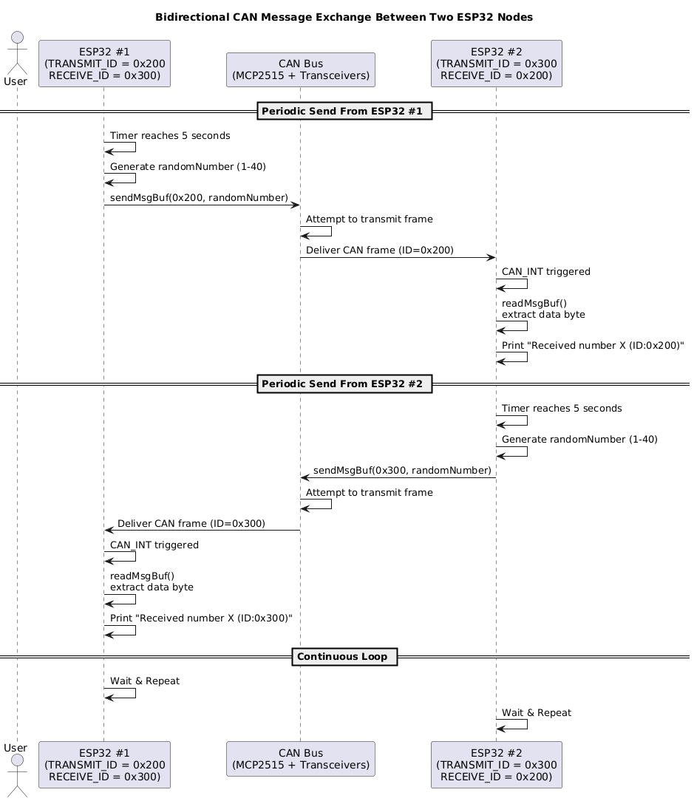
The sequence diagram illustrates the overall system workflow. Although we currently only have skeleton code for the CAN implementation, the intended functionality is to reliably transmit information between nodes without interruption.

What if it gets disconnected?
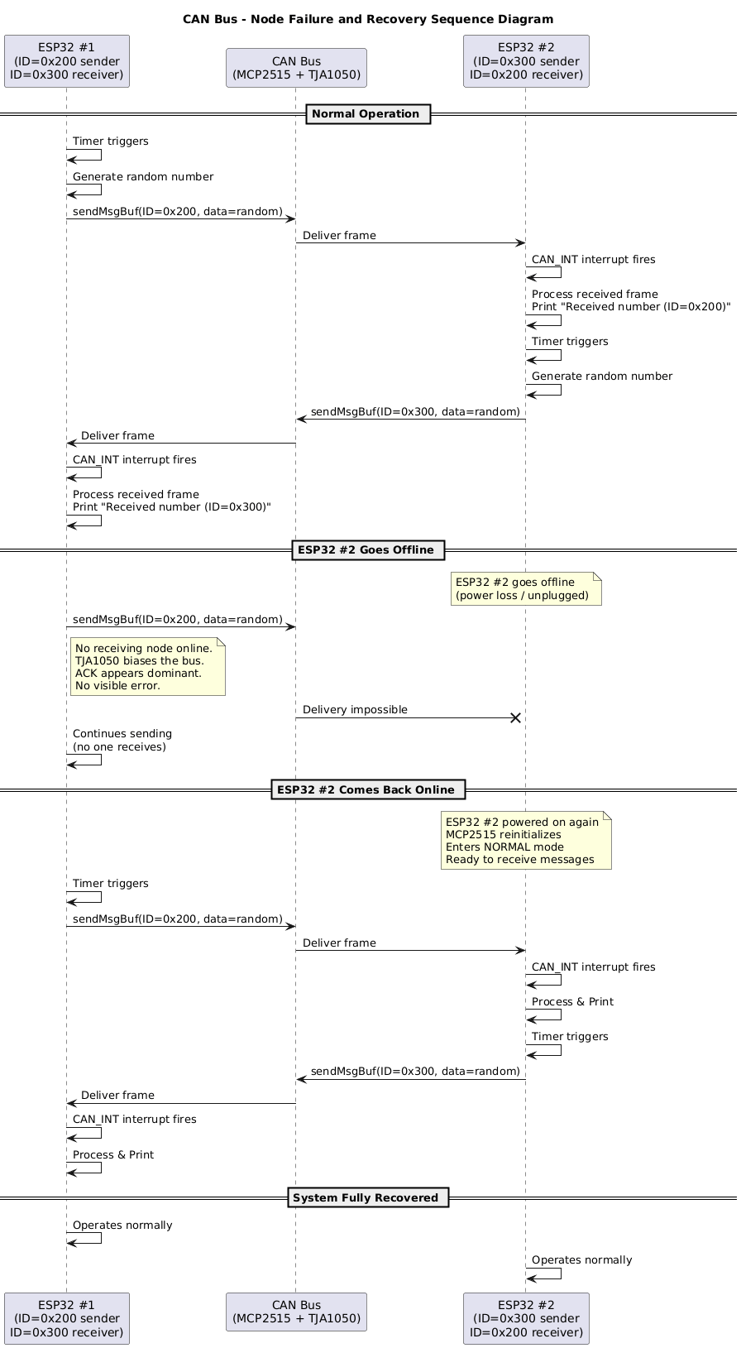
The transceiver used in our design does not perform ACK checking. As a result, if a node goes offline, no error code is generated. The system continues transmitting messages regardless of a node’s status. Once the offline node reconnects, it automatically resumes receiving the ongoing communication. This provides a built-in reconnection capability and helps maintain system robustness.
Wireless Communication
Protocol MQTT, Model Publish and subscribe
- Pros
  - Lightweight on the systems
  - QoS levels
  - Retained message
- Cons
  - Needs a broker (message could be slowed down)
  - Not a true peer to peer
Protocol WebSocket, Model Persistent bi-directional TCP
- Pros
  - Real time updates over standard web protocol
- Cons
  - More code complexity
  - Typically paired with Http
Protocol ESP-Now, Model Peer to Peer
- Pros
  - No wifi-Network required
  - Ultra low latency
  - Low power
- Cons
  - Range limited
  - Small payloads
  - No Ip layer
Protocol CAN Bus (with wifi gateway), Model Bus topology
- Pros
  - Robust
  - Real-Time
- Cons
  - Not wireless by default
  - Code complexity for wireless
  - Needs hardware transceivers

After careful considerations between these communication protocols and models, I have decided it is best to use this following protocol in order for it to communicate wirelessly.
MQTT – Pub & Sub model
ESP-Now protocol - Peer to peer

So why these two protocols and models.
MQTT:
- Each device esp32 acts as an MQTT client
- A broker routes messages between them
- Devices Publish the data and subscribe to topics
- Why is it suitable for this project?
  - Chargers acts independently but share real-time data efficiently
  - Low network overhead and easy asynchronous communication
  - Perfect for telemetry and status updates every few seconds
- Communication topology
  - All ESP32 connect to one broker over WiFi
  - The broker handles message distribution no charger needs to know about others directly
  - Scales cleanly from 2 to many chargers
  - The dashboard only subscribes, no direct control path needed.
  - If charger disconnects, others still work.
- The data format for this communication model works best as JSON
- Communication protocol
  - MQTT 3.1.1
  - MQTT 5.0
- Underlying transport TCP over WiFi
- ESP32 has mature MQTT libraries
- Works well with the dashboard’s periodic updates
- Components needed are
  - ESP32 5x
  - MQTT broker
  - WiFi Access point (phone hot spot for prototype)
Why choose this communication protocol and model?
MQTT is simple, well-supported and perfect for small wireless projects like ours. It lets all the ESP32 charging stations send data to one place, and the dashboard can easily listen to those updates without complex setup. When one Charging station is down and mode changes a message is marked retained. The broker keeps the last message for that topic. Then when any new or reconnected device subscribes to that topic, it immediately receives the latest retained message. For the first come first serve charger down problem. Each charger announces itself and its connection time throught MQTT topics. The system assigns priority numbers and publishes this as a retained message. When a charger reconnects, it subscribes to that retained topic and automatically learns its current priority, ensuring consistent behavior even after disconnection.
(Something like this)
- At start
  - Chargers 1,2 and 3 connect in that order
  - Each one publishes to /chargers/connected with a timestamp
  - They also agree
    - Priority: C1=1, C2=2, C3=3
    - This table is published and retained on /chargers/priority
- Charger 2 goes offline
  - The broker automatically marks /chargers/C2/Status offline
  - Chargers 1 & 3 see fewer online peers
  - They rebalance their power share
- Charger 2 comes back
  - When it reconnects, it subscribes to /charger/priority
  - It immediately gets the retained priority table, sees it was #2
  - Then you can update the table to make C2=3 priority
So why this protocol and model?
I chose MQTT pub & sub model because it perfectly matches our system’s decentralized design. Each charger works independently but still needs to share information about load, mode, and status. MQTT provides an easy way to exchange these messages wirelessly using a lightweight protocol designed for IoT devices like the ESP32. It also includes built-in reliability features, retained messages for reconnections and last-will messages for offline detection. So our system stays consistent even if some chargers temporarily go down. Finally, MQTT is simple to implement. Well-documented, and scales smoothly, making it the most practical and reliable choice for our wireless embedded load balancing project.

ESP-Now:
- Suitable communication model
  - Model:
    - Each ESP32 Charger can send small messages directly to another ESP32. No broker or wifi network needed
    - Devices communicate using their MAC addresses.
    - The dashboard can also be one of the peers, receiving data from all chargers.
  - Why it fits?
    - Removes the middleman
    - Very low latency
    - Great when you want your system to keep working even without WiFi infrastructure.
- Communication topology
  - You can design it in two simple ways
    - Star: all chargers send data directly to the dashboard ESP32
    - Mesh: each charger can talk to others
  - With only 4 chargers + 1 dashboard, a star setup is easiest
  - Why if fits?
    - Simple structure, every ESP knows exactly who to talk to
    - No single broker to fail, communication continues even if one device goes offline.
- Data format and model fit
  - ESP-NOW messages are limited to about 250 bytes, so keep them small
  - Example:
    - { “id”; “C1”; “kW”; 7.1, “mode”; “dynamic” }
  - Why it fits?
    - Perfect for sending short sensor readings or control data like charging power or mode.
    - Fast, minimal delay, Ideal for real-time control loops
- Communication protocol
  - Protocol ESP-Now
    - Works on top of the same radio as WiFi but doesn’t need a router
    - Based on IEEE 802.11 Action frames (low level WiFi packets)
    - One ESP can be a controller or all can be peers
  - Why it fits?
    - Wireless communication without needing network setup or internet
    - Very low energy use and stable even if WiFi is unavailable
    - Great for local or demo setups where you just power on the devices and they start talking
  - Components necessary
    - ESP32 x5
    - Bridge ESP32
    - Power + 2.4 GHz antenna (built in)
- Why choose this model?
  - Decentralized communication
    - Every charger talks directly, no broker or network dependency.
    - Even if one device fails, others still share data.
  - Very low latency & overhead
    - Packets travel instantly, making it great for real-time coordination
  - Simple deployment
    - Works anywhere: plug in the ESPs and they communicate automatically
  - Energy efficient
    - ESP-Now uses less power and less bandwidth than WiFI
  - Limitations
    - Range
    - Payloads are small
    - Harder to integrate with a web based dashboard.
So why choose ESP-Now
We chose ESP-Now as a candidate because it allows our ESP32 charging stations to communicate directly with each other without relying on a central broker or WiFi network. This makes the system more decentralized and fault tolerant, if one device goes down, the others continue to exchange data.
ESP-Now is designed for fast, low power communication between nearby ESP devices, which suits our small network of four chargers and one dashboard. It sends short packets of data with very low delay, making it ideal for real-time updates such as power usage and mode changes.
The trade off is that it has a smaller range and limited message size, and connecting to external dashboards requires a bridge, but it offers true peer to peer reliability within our system.

Reconnection and sync:
(Something like this)
- When all chargers start
  - Each charger announces itself with a short “Hello” broadcast
  - They collect all these messages and agree on a priority order based on who joined first (FCFS)
  - One charger can act as a “leader” to share the agreed list with everyone.
- When a charger goes offline
  - The others notice it stopped sending updates for a few seconds
  - They mark it as offline and rebalance the load automatically
  - The leader rebroadcasts the updated table to everyone
- When that charger comes back
  - It sends a “Hello” message again
  - A nearby charger responds with the latest system table
  - The returning charger updates its own state, it now knows the current mode and its new priority
  - All chargers are again synchronized
- What makes this work
  - Periodic broadcasts: each charger sends a small status packet every few seconds
  - Timeout detection: if a charger’s signal is missing for too long, mark it offline
  - Leader or shared rebroadcast: one node that detects change updates everyone else
  - Lightweight data: tiny JSON or binary messages
Summary
With ESP-Now, each charger maintains its own list of active peers and priorities. Chargers periodically broadcast their status so that if one drops offline, the others automatically adjust. When the charger reconnects, it announces itself and quickly receives the latest system state from a peer, allowing it to rejoin the network seamlessly without needing a central broker.

Conclusion
After taking this into consideration, the group has decided to use a hybrid system to communicate between components. Communication between the “building” and “charging port” microcontrollers will utilize a CAN bus connection. Communication between the dashboard and other components will be facilitated through MQTT.
This way, the charging ports will benefit from the stability and security of a wired network while still being able to operate independently. The dashboard can send or collect data while not being tethered to a physical location and is relatively easy to set up. Furthermore, esp32's will be used to simulate these entities, which is a microcontroller that already supports MQTT functionality.

Final choice 1, MQTT:

Identified Messages in the System

Wi-Fi Setup
- Dashboard ESP → Wi-Fi: WiFi.begin(ssid, password)
- Charging Station ESP → Wi-Fi: WiFi.begin(ssid, password)
- Dashboard ESP → Dashboard ESP: Wait until WL_CONNECTED
- Charging Station ESP → Charging Station ESP: Wait until WL_CONNECTED

MQTT Connection
- Dashboard ESP → Broker: client.connect()
- Charging Station ESP → Broker: client.connect(("Station" + id))
- Charging Station ESP → Broker: client.subscribe("station/{id}/mode")
- Dashboard ESP → Broker: client.subscribe("station/+/status")

Status Publishing
- Charging Station ESP → Broker:
client.publish("station/{id}/status", payload)
Payload example: {"alive":true,"power":X,"mode":"Y"}
- Broker → Dashboard ESP: Forward station/{id}/status message
- Dashboard ESP → Dashboard ESP: Update deviceOnline map

Mode Change
- User → Dashboard ESP: HTTP request to change mode
- Dashboard ESP → Broker: client.publish("station/{id}/mode", newMode)
- Broker → Charging Station ESP: Deliver station/{id}/mode message
- Charging Station ESP → Charging Station ESP: callback() → state.setMode(newMode)

Internal Periodic Messages
- Charging Station ESP → Charging Station ESP: update() calls publishStatus() every 2 seconds
- Charging Station ESP → Charging Station ESP: reconnect() if MQTT disconnected
- Dashboard ESP → Dashboard ESP: Render HTML page with DEAD/ALIVE status
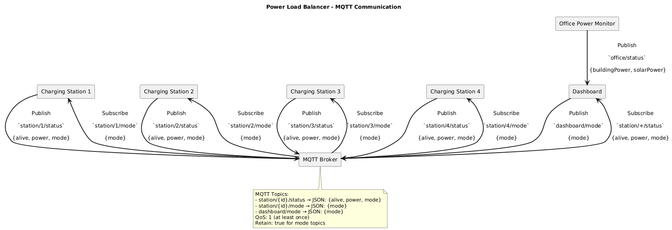
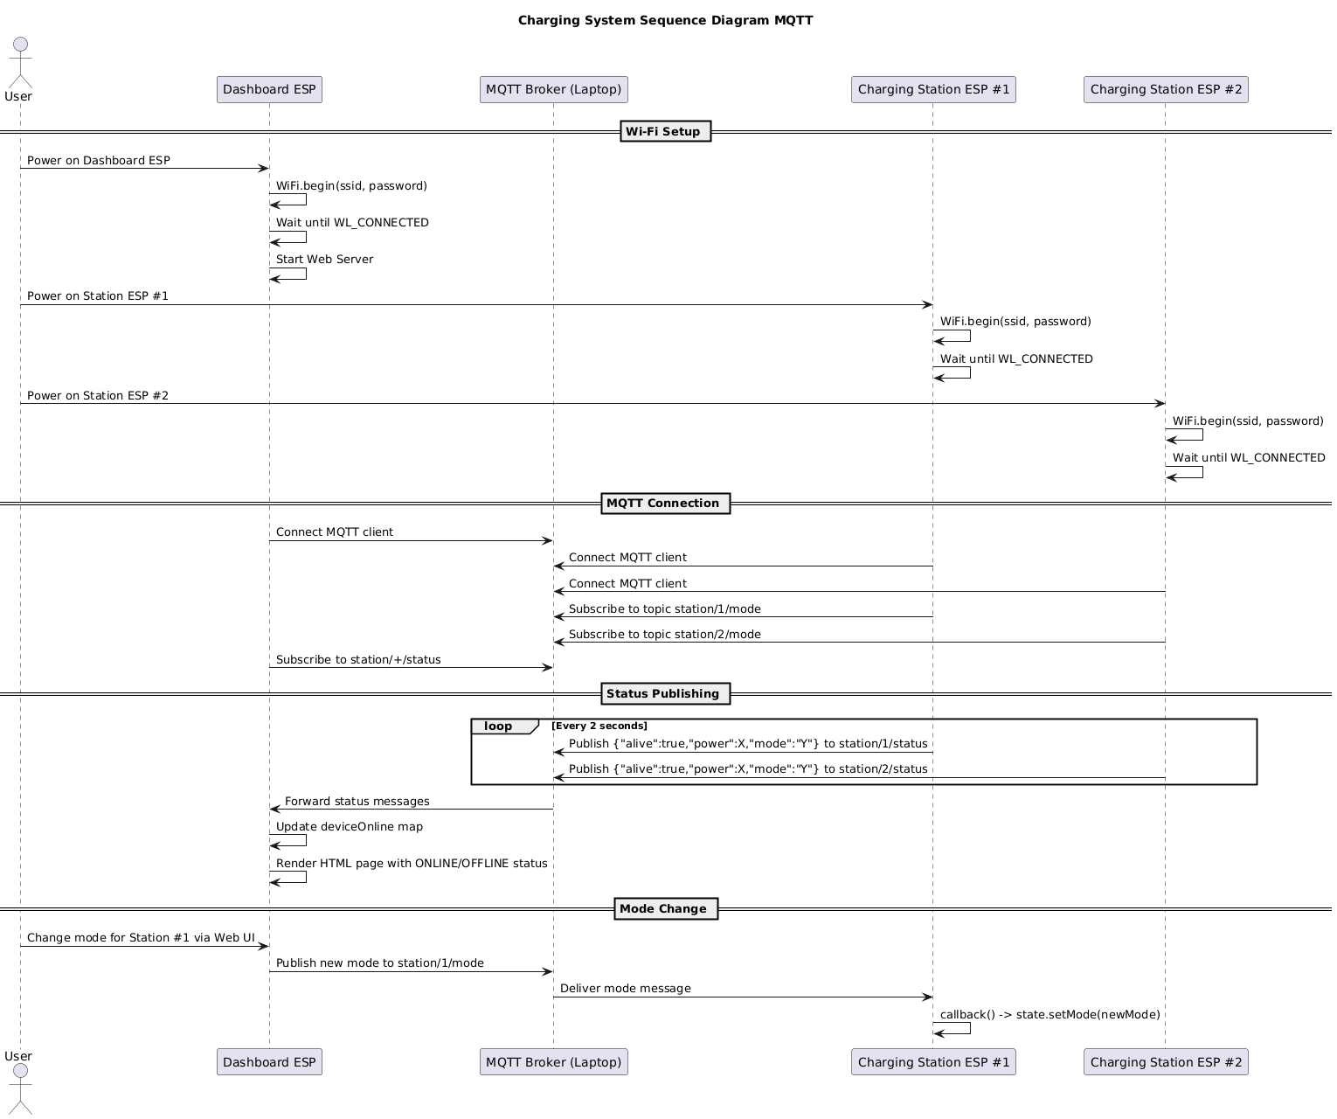

Hardware design
For this project it is out of scope to measure and control the power of a building and EV charging station. Therefore, the concept and function of the algorithm will be proven by implementing it on a smaller scale using low voltages and currents, this is also a much safer option in the early development stage.

Microcontroller
For each of module in the system a microcontroller is required to handle the communication with the other modules and to control the actuators according to the logic controlled by an algorithm.
The actuators and sensors connected to this microcontroller will merely require several IO ports which nearly all common microcontrollers possess. Therefore, the requirements for the microcontroller will mostly depend on the communication protocol.
For this project the ESP32 is the proposed option, this microcontroller is easy to implement which fits in the short timeframe of this project. Furthermore, this microcontroller has built-in wireless communication capabilities which will facilitate communication with the GUI.

Current measuring
For this project it is required to measure current in order to calculate the power usage of a module. A hall effect based current sensor is a good option. They are very easy to implement an example can be seen in the image below using the ACS712 sensor.
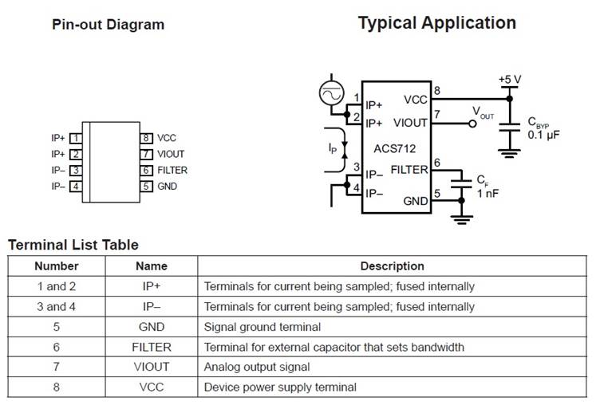
Figure 1 ACS712 current sensor
This sensor can also be used by implementing a module which already has this circuit built in such as this example.
For this project the latter option is preferable due to time constraints. This project will use such a module. Another option is to use a module that is also capable of measuring the voltage, this will make it very easy to calculate the power consumption. An example of such a module is this.

Current limiting
In order for the system to control the power going to each module it will need to be able to limit the current. A good option to limit the current is by using a current-limit switch. Typically the current limit is a function of the voltage drop across an external resistor. For this project however we want the current limit to be digitally programmable so it can be controlled by an algorithm. Therefore the external resistor will be replaced by a programmable potentiometer. An example of such a circuit can be seen in the image below.
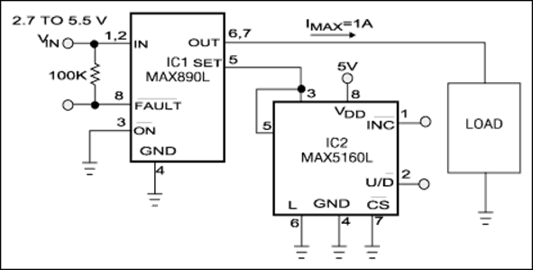
Figure 2 Current limit switch
This current limit switch will allow the current to increase up to the programmed limit. In the example above the digital potentiometer is 50kΩ with 32 increments. This will give a resolution of 31,25 mA for setting the current limit.

Software design

Inleiding
Voor het groepsproject is een softwaresysteem ontworpen dat het laadproces van elektrische voertuigen en het energieverbruik van een gebouw coördineert. De structuur van het systeem is weergegeven in het UML-klassendiagram. Hierin zijn verschillende subsystemen te zien, waaronder de charging station, building en GUI (Graphical User Interface).
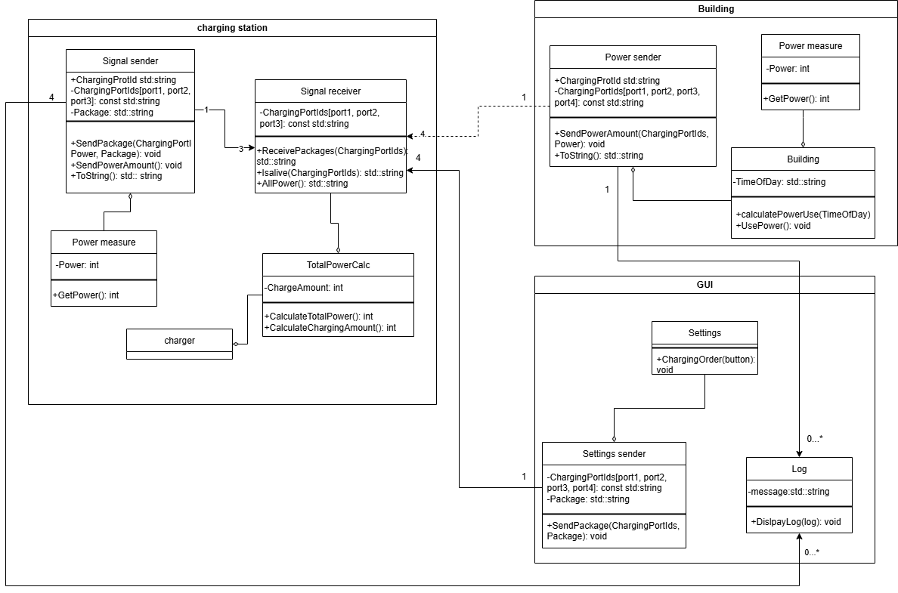
De klassen communiceren met elkaar via objectrelaties, waarbij gegevens over laadpoorten, vermogenswaarden en instellingen worden uitgewisseld. Om deze communicatie en gegevensopslag efficiënt en gestructureerd te realiseren, is gekozen voor het gebruik van een JSON-bestand (JavaScript Object Notation).

JSON
JSON is een lichtgewicht dataformaat dat gemakkelijk leesbaar is voor zowel mensen als machines. Er zijn meerdere redenen waarom JSON een geschikte keuze is voor dit project:
- Menselijke leesbaarheid:
JSON gebruikt een eenvoudige structuur met sleutel-waardeparen, waardoor het bestand overzichtelijk en eenvoudig aan te passen is zonder speciale software.
- Taalonafhankelijkheid:
JSON kan in vrijwel elke programmeertaal worden gelezen en geschreven, waaronder C++, C#, Python en Java. Dit is we willen waarschijnlijk de GUI in C# maken daarvoor is dit handig.
- Makkelijk te parsen:
JSON-structuren kunnen eenvoudig worden geconverteerd naar objecten binnen de software. Dit maakt het mogelijk om bijvoorbeeld instellingen of meetwaarden rechtstreeks in te laden als objecten binnen de code.
- Geschikt voor communicatie tussen modules:
In plaats van directe afhankelijkheden tussen klassen, kan de data-uitwisseling via JSON verlopen. Zo blijft het systeem modulair en schaalbaar.

Mogelijke opstelling van het JSON-bestand
De JSON-file kan dienen als communicatiestructuur tussen subsystemen zoals de charging station, building, en GUI. Een voorbeeld van de structuur:
{
"ChargingStation": {
"Ports": [
{"PortId": "Port1", "Power": 9700, "Status": "Charging"},
{"PortId": "Port2", "Power": 9700, "Status": "Charging"},
{"PortId": "Port3", "Power": 600, "Status": "Charging"}
],
"TotalPower": 6300
},
"Building": {
"TimeOfDay": "14:30",
"PowerUsage": 80000
},
"GUI": {
"Settings": {
"PriorityMode": "Balanced",
"MaxPowerLimit": 100000
},
"Logs": [
{"Message": "Charging started at Port1", "Timestamp": "14:32"},
{"Message": "Building load adjusted", "Timestamp": "14:33"}
]
}
}

Werking in de software
- De Signal Sender en Receiver-klassen gebruiken JSON om pakketten met laad- en vermogensinformatie te verzenden en ontvangen.
- De GUI leest en schrijft JSON-data bij het wijzigen van instellingen of het opslaan van logbestanden.
- De Building-klasse kan via JSON communiceren over het actuele stroomverbruik, zodat het laadstation zijn vermogen kan afstemmen.
Door JSON te gebruiken als tussenlaag ontstaat een duidelijk gescheiden communicatiestructuur, wat onderhoud, debugging en uitbreidbaarheid van de software aanzienlijk vereenvoudigt.

